Features Selection Methods

Univariate Feature Selection Correlation Between Features With Heat-Map
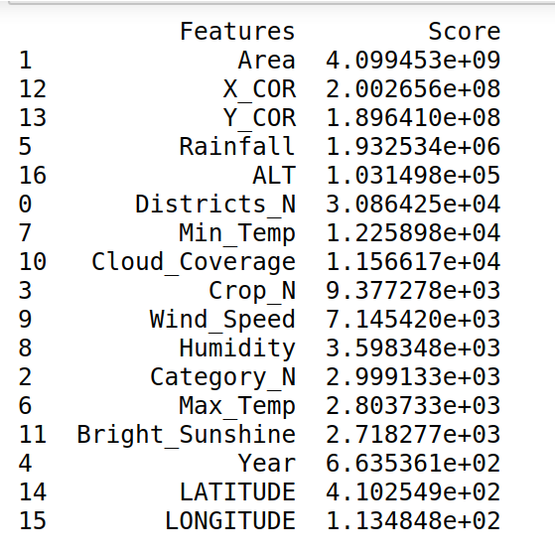
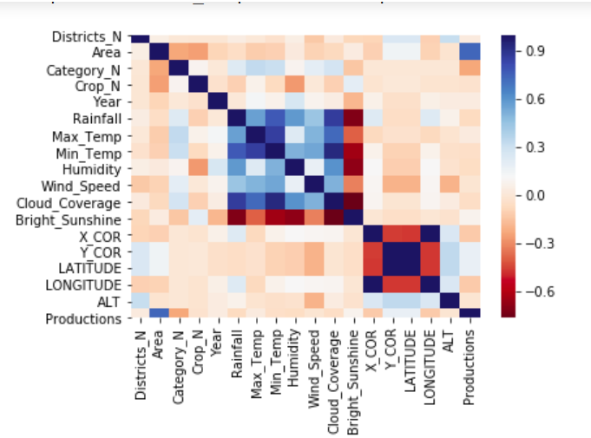

1. Best 12 Features: ( Area, X_Cor, Y_Cor, Rainfall, Alt, Districts_N, Min_Temp, Cloud_Coverage, Crop_N, Wind_Speed, Humidity, Category_N )

2. Best 10 Features: ( Area, X_Cor, Y_Cor, Rainfall, Alt, Districts_N, Min_Temp, Cloud_Coverage, Crop_N, Wind_Speed )

Variance Inflation Factor
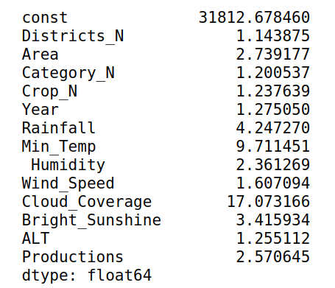

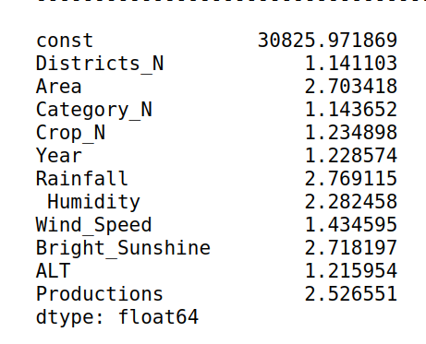

1. Best 12 Features: ( Districts_N, Area, Category_N, Crop_N, Year, Rainfall, Min_Temp, Humidity, Wind_Speed, Cloud_Coverage, Bright_Sunshine, Alt )

2. Best 10 Features: ( Districts_N, Area, Category_N, Crop_N, Year, Rainfall, Humidity, Wind_Speed, Bright_Sunshine, Alt )

Regression Model Analysis

1. Linear Regression

Features | Training Set | Test Set | Feature Selection | Accuracy
10 | 80% | 20% | Variance Inflation Factor | 57 %
12 | 80% | 20% | Variance Inflation Factor | 65 %
17 | 80% | 20% | Variance Inflation Factor | 62 %
10 | 80% | 20% | Univariate | 59 %
12 | 80% | 20% | Univariate | 62 %
17 | 80% | 20% | Univariate | 63 %

2. Lasso Regression

Features | Training Set | Test Set | Feature Selection | Parameter | Accuracy
10 | 80% | 20% | Variance Inflation Factor | 0.1 | 55 %
12 | 80% | 20% | Variance Inflation Factor | 0.1 | 56 %
17 | 80% | 20% | Variance Inflation Factor | 0.1 | 55 %
10 | 80% | 20% | Univariate | 0.1 | 56 %
12 | 80% | 20% | Univariate | 0.1 | 57 %
10 | 80% | 20% | Variance Inflation Factor | 0.2 | 51 %
12 | 80% | 20% | Variance Inflation Factor | 0.2 | 51 %
17 | 80% | 20% | Variance Inflation Factor | 0.2 | 50 %
10 | 80% | 20% | Univariate | 0.2 | 52 %
12 | 80% | 20% | Univariate | 0.2 | 53 %
10 | 80% | 20% | Variance Inflation Factor | 0.3 | 46 %
12 | 80% | 20% | Variance Inflation Factor | 0.3 | 46 %
17 | 80% | 20% | Variance Inflation Factor | 0.3 | 45 %
10 | 80% | 20% | Univariate | 0.3 | 47 %
12 | 80% | 20% | Univariate | 0.3 | 48 %
10 | 80% | 20% | Variance Inflation Factor | 0.4 | 39 %
12 | 80% | 20% | Variance Inflation Factor | 0.4 | 37 %
17 | 80% | 20% | Variance Inflation Factor | 0.4 | 38 %
10 | 80% | 20% | Univariate | 0.4 | 40 %
12 | 80% | 20% | Univariate | 0.4 | 40 %

3. Ridge Regression

Features | Training Set | Test Set | Feature Selection | Parameter | Accuracy
10 | 80% | 20% | Variance Inflation Factor | 0.1 | 62 %
12 | 80% | 20% | Variance Inflation Factor | 0.1 | 60 %
17 | 80% | 20% | Variance Inflation Factor | 0.1 | 63 %
10 | 80% | 20% | Univariate | 0.1 | 61 %
12 | 80% | 20% | Univariate | 0.1 | 61 %
5
10 | 80% | 20% | Variance Inflation Factor | 0.2 | 62 %
12 | 80% | 20% | Variance Inflation Factor | 0.2 | 60 %
17 | 80% | 20% | Variance Inflation Factor | 0.2 | 63 %
10 | 80% | 20% | Univariate | 0.2 | 61 %
12 | 80% | 20% | Univariate | 0.2 | 61 %
10 | 80% | 20% | Variance Inflation Factor | 0.3 | 62 %
12 | 80% | 20% | Variance Inflation Factor | 0.3 | 60 %
17 | 80% | 20% | Variance Inflation Factor | 0.3 | 63 %
10 | 80% | 20% | Univariate | 0.3 | 61 %
12 | 80% | 20% | Univariate | 0.3 | 61 %
10 | 80% | 20% | Variance Inflation Factor | 0.4 | 62 %
12 | 80% | 20% | Variance Inflation Factor | 0.4 | 60 %
17 | 80% | 20% | Variance Inflation Factor | 0.4 | 63 %
10 | 80% | 20% | Univariate | 0.4 | 61 %
12 | 80% | 20% | Univariate | 0.4 | 61 %

4. Bayesian Ridge

Features | Training Set | Test Set | Feature Selection | Accuracy
10 | 80% | 20% | Variance Inflation Factor | 62 %
12 | 80% | 20% | Variance Inflation Factor | 59 %
17 | 80% | 20% | Variance Inflation Factor | 63 %
10 | 80% | 20% | Univariate | 63 %
12 | 80% | 20% | Univariate | 59 %

5. Support Vector Regressor

Features | Training Set | Test Set | Feature Selection | Accuracy | Cross Validation
10 | 80% | 20% | Variance Inflation Factor | 88 % | 83 % ( cv = 200 )
12 | 80% | 20% | Variance Inflation Factor | 89 % | 84% (cv= 200)
17 | 80% | 20% | Variance Inflation Factor | 92 %
10 | 80% | 20% | Univariate | 88 %
12 | 80% | 20% | Univariate | 89 %

6. K-Nearest Neighbor ( n_neighbors =5 )

Features | Training Set | Test Set | Feature Selection | Accuracy | Cross Validation
10 | 80% | 20% | Variance Inflation Factor | 93 % | 90% (CV = 3500 )
12 | 80% | 20% | Variance Inflation Factor | 92 % | 90% (CV = 3500 )
17 | 80% | 20% | Variance Inflation Factor | 93 %
10 | 80% | 20% | Univariate | 89 %
12 | 80% | 20% | Univariate | 90 %

7. Decision Tree

Features | Training Set | Test Set | Feature Selection | Accuracy | Cross Validation
10 | 80% | 20% | Variance Inflation Factor | 95 % | 88% (CV = 57 )
12 | 80% | 20% | Variance Inflation Factor | 95 % | 88% (CV = 57 )
17 | 80% | 20% | Variance Inflation Factor | 96 %
10 | 80% | 20% | Univariate | 91 %
12 | 80% | 20% | Univariate | 94 %

8. Random Forest ( n_estimators =5 )

Features | Training Set | Test Set | Feature Selection | Accuracy | Cross Validation
10 | 80% | 20% | Variance Inflation Factor | 97 % | 88% (CV = 57 )
12 | 80% | 20% | Variance Inflation Factor | 95 % | 89% (CV = 57 )
17 | 80% | 20% | Variance Inflation Factor | 96 %
10 | 80% | 20% | Univariate | 94 %
12 | 80% | 20% | Univariate | 94 %

9. Artificial Neural Network (hidden_layer_sizes = [ 100, 75, 50, 25 ] )

Features | Training Set | Test Set | Feature Selection | Accuracy
10 | 80% | 20% | Variance Inflation Factor | 96 %
12 | 80% | 20% | Variance Inflation Factor | 96 %
17 | 80% | 20% | Variance Inflation Factor | 96 %
10 | 80% | 20% | Univariate | 92 %
12 | 80% | 20% | Univariate | 94 %

Summery:

SL | Models | Features | Feature Selection Model | Accuracy | Cross Validation | Cross Validation
1 | Support Vector Regressor | 10 | Variance Inflation Factor | 88 % | 83 % ( CV = 200 ) | 59% ( CV = 10 )
2 | Support Vector Regressor | 12 | Variance Inflation Factor | 89 % | 84% (CV = 200) | 62% ( CV = 10 )
3 | Random Forest | 10 | Variance Inflation Factor | 97 % | 88% (CV = 57 ) | 66% ( CV = 10 )
4 | Random Forest | 12 | Variance Inflation Factor | 95 % | 89% (CV = 57 ) | 62% ( CV = 10 )
5 | K-Nearest Neighbor | 17 | Variance Inflation Factor | 93 % | 90% (CV = 3500 ) | 55% ( CV = 10 )
6 | K-Nearest Neighbor | 12 | Variance Inflation Factor | 92 % | 90% (CV = 3500 ) | 54% ( CV = 10 )
7 | Decision Tree | 10 | Variance Inflation Factor | 95 % | 88% (CV = 57 ) | 56% ( CV = 10 )
8 | Decision Tree | 12 | Variance Inflation Factor | 95 % | 88% (CV = 57 ) | 58% ( CV = 10 )

